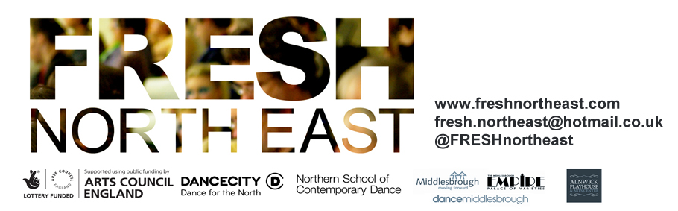

Application Information

Wednesday 5 December at Dance City Newcastle, 6.30pm – 8.45pm

Moving Art Management are now seeking proposals from dance artists to share work in progress at FRESH North East at Dance City Newcastle on Wednesday 5 December 2018.

FRESH North East provides an open forum for sharing and discussing new work. Artists present work at an early stage of development in an informal studio setting. FRESH North East is designed to bridge the gap between what happens in the studio and on the stage providing opportunity for experimentation, and to foster discussion of new work.

The programme will include up to 5 artists/companies, each sharing up to 10mins of work in progress. The sharing’s will happen in succession, followed by a facilitated feedback discussion. Artists have the opportunity to pose questions to the audience gaining specific and valuable feedback. There will also be networking opportunities before and after the event.

Moving Art Management will collaborate with a photographer and a videographer as part of the event and artists/companies will be given the high-quality images and footage after the event to use in the promotion of their work. (Moving Art Management & the photographer/videographer will own the copyright of the images and footage, and when used by artist/companies must be fully credited.)

FRESH North East will take place in an informal studio setting with little or no technical support available at the event. During the day on Wednesday 5 December, artists/companies will be given rehearsal times in a space (may not be the performance space) of approx. 25mins.

A bursary of £100 is available per artist/company to support their involvement in the event. (Artists/companies are responsible for their own self-employment taxes.)

Please complete the Application Form, as well as the Equal Opportunities Monitoring Form and return to movingartmanagement@gmail.com by Monday 5 November at 12noon. If there are any further questions about the event, please don’t hesitate to contact us.

We look forward to hearing from you,

Rachel Jean Birch & Hannah Marshall
Moving Art Management | www.movingartmanagement.com

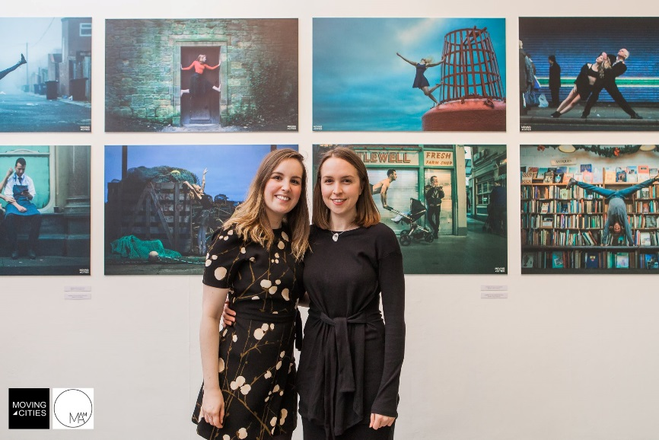
Hannah Marshall (left) Rachel Jean Birch (right)
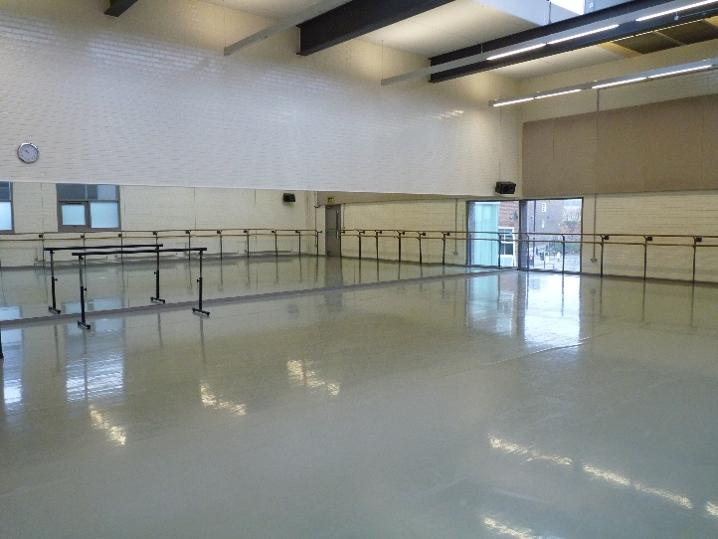
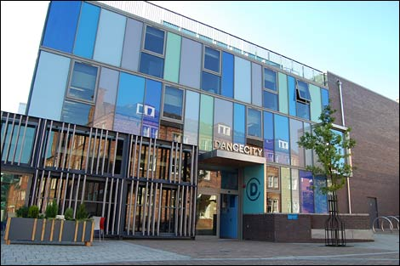
Dance City, Temple Street, Newcastle, NE1 4BR – Studio 4 on the top floor is where FRESH North East will take place. Lift access available.

Parking available at the Grainger Multi Story next door to Dance City, or street parking is available nearby at the Discovery Museum/Westgate Road.

Nearest Metro stations are St James or Central Station.

For more information about Dance City please visit www.dancecity.co.uk

