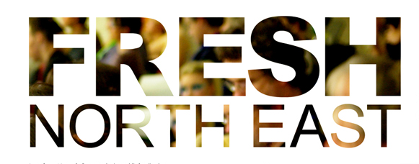

Application Form
The deadline for applications for FRESH North East at Dance City Newcastle on Monday 2 December, is Monday 4 November at 5pm. For further information about the event and the application process please refer to the call out on our website www.movingartmanagement.com
Please return application forms to movingartmanagement@gmail.com
Please provide as much detail as possible
Full Name
Postcode
Email
Telephone
Website
Twitter
Link to clip of work
How did you hear about FRESH North East?

Artist/Company Name
Artist/Company Background
Title of Piece
Length of work
Description of work
(Stating any necessary technical requirements, set, props etc.)
Full name of performer/s
Credits e.g. music (including artist and track title), props
Please let us know if you have any access requirements.

Please also complete and return the Equal Opportunities Monitoring Form, thank you.
www.movingartmanagement.com

